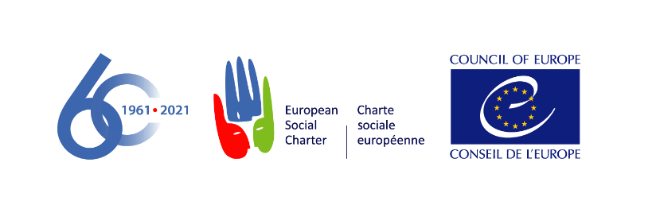

European Committee of Social Rights
Comité européen des Droits sociaux

DECISION ON ADMISSIBILITY

8 September 2021

Validity Foundation v. Finland

Complaint No. 197/2020

The European Committee of Social Rights, committee of independent experts established under Article 25 of the European Social Charter (“the Committee”), during its 322nd session attended by:

Karin LUKAS, President
Eliane CHEMLA, Vice-President
Aoife NOLAN, Vice-President
Giuseppe PALMISANO, General Rapporteur
József HAJDU
Barbara KRESAL
Kristine DUPATE
Karin Møhl LARSEN
Yusuf BALCI
Ekaterina TORKUNOVA
Tatiana PUIU
Paul RIETJENS
George THEODOSIS
Mario VINKOVIC
Miriam KULLMANN

Assisted by Henrik KRISTENSEN, Deputy Executive Secretary

Having regard to the complaint registered on 26 October 2020 as number 197/2020, lodged by Validity Foundation – Mental Disability Advocacy Center (Validity), and signed by Ann Campbell, Co-Executive Director of Validity requesting the Committee to find that the situation in Finland is not in conformity with Articles 11, 14 and 15 as well as Article E in conjunction with each of the aforementioned provisions of the Revised European Social Charter (“the Charter”);

Having regard to the observations of the Government of Finland ("the Government") on the admissibility of the complaint, registered on 29 January 2021;

Having regard to the response from Validity to the Government’s observations, registered on 31 March 2021;

Having regard to the reply by the Government to Validity’s response, registered on 25 May 2021;

Having regard to the Charter and, in particular to Articles 11, 14, 15 and E, which read as follows:

Article 11 – The right to protection of health

Part I: “Everyone has the right to benefit from any measures enabling him to enjoy the highest possible standard of health attainable.”

Part II: “With a view to ensuring the effective exercise of the right to protection of health, the Parties undertake, either directly or in cooperation with public or private organisations, to take appropriate measures designed inter alia:

1. to remove as far as possible the causes of ill-health;

2. to provide advisory and educational facilities for the promotion of health and the encouragement of individual responsibility in matters of health;

3. to prevent as far as possible epidemic, endemic and other diseases, as well as accidents.”

Article 14– The right to benefit from social welfare services

Part I: “Everyone has the right to benefit from social welfare services.”

Part II: “With a view to ensuring the effective exercise of the right to benefit from social welfare services, the Parties undertake:

1. to promote or provide services which, by using methods of social work, would contribute to the welfare and development of both individuals and groups in the community, and to their adjustment to the social environment;

2. to encourage the participation of individuals and voluntary or other organisations in the establishment and maintenance of such services.

Article 15 – The right of persons with disabilities to independence, social integration and participation in the life of the community

Part I: “Disabled persons have the right to independence, social integration and participation in the life of the community.”

Part II: “With a view to ensuring to persons with disabilities, irrespective of age and the nature and origin of their disabilities, the effective exercise of the right to independence, social integration and participation in the life of the community, the Parties undertake, in particular:

- to take the necessary measures to provide persons with disabilities with guidance, education and vocational training in the framework of general schemes wherever possible or, where this is not possible, through specialised bodies, public or private;

- to promote their access to employment through all measures tending to encourage employers to hire and keep in employment persons with disabilities in the ordinary working environment and to adjust the working conditions to the needs of the disabled or, where this is not possible by reason of the disability, by arranging for or creating sheltered employment according to the level of disability. In certain cases, such measures may require recourse to specialised placement and support services;

- to promote their full social integration and participation in the life of the community in particular through measures, including technical aids, aiming to overcome barriers to communication and mobility and enabling access to transport, housing, cultural activities and leisure.”

Article E – Non-discrimination

“The enjoyment of the rights set forth in this Charter shall be secured without discrimination on any ground such as race, colour, sex, language, religion, political or other opinion, national extraction or social origin, health, association with a national minority, birth or other status.”

Having regard to the 1995 Additional Protocol to the European Social Charter providing for a system of collective complaints (“the Protocol”);

Having regard to the Rules of the Committee adopted by the Committee on 29 March 2004 at its 201st session and last revised on 19 May 2021 at its 320th session ("the Rules”);

Having deliberated on 7 and 8 September 2021;

Delivers the following decision, adopted on this latter date:

- Validity alleges that the measures taken by the Government to tackle the COVID-19 pandemic in spring 2020 violate the rights of persons with disabilities under Article 11 (the right to health), Article 14 (the right to social services) and Article 15 (the right to independence and inclusion in the community) as well as Article E (non-discrimination) in conjunction with each of the invoked provisions of the Charter. Validity argues in particular that:

- the Government did not adopt appropriate measures to protect the life and health of persons (Article 11) during the pandemic where residential institutions became hotbeds for the spread of the virus;
- the Government failed to fulfil its obligation to ensure that persons with disabilities were immediately provided the opportunity to move from these units into the community with appropriate supports;
- the Government also failed to ensure that persons with disabilities had access to health care services and facilities on a basis of non-discrimination.
- the measures adopted by the Government led to the complete isolation of persons with disabilities living in “housing service units” thus limiting their right to social services, and to independence and inclusion in the community as enshrined in Articles 14 and 15 of the Charter.

- Finally, Validity asks the Committee to prioritise the examination of the admissibility of this complaint as an “immediate measure” pursuant to Article 36 of the Rules, because of the gravity of the matters complained of.

- In its observations, the Government refutes all of the above allegations as unfounded. It considers therefore that the complaint does not fulfil the conditions for admissibility under Article 4 of the Protocol and should be declared inadmissible.

- In its response to the Government’s observations, Validity emphasises that the complaint concerns the rationality and reasonableness of the measures taken by the Government and their compatibility with the human rights of persons with disabilities.

- In its reply, the Government reiterates its previous observations and states that the complaint does not fulfil the conditions for admissibility under Article 4 of the Protocol.

THE LAW

- The Committee observes that, in accordance with Article 4 of the Protocol, which was ratified by Finland on 17 July 1998 and entered into force on 1 September 1998, the complaint has been submitted in writing and concerns Articles 11, 14 and 15, provisions accepted by Finland when it ratified the Charter on 21 June 2002 as well as Article E. Finland is bound by these provisions since the entry into force of this treaty in its respect on 1 August 2002.

- The Committee notes that, in accordance with Articles 1 (b) and 3 of the Protocol, Validity is an international non-governmental organisation with participatory status with the Council of Europe. It is included on the list established by the Governmental Committee of non-governmental organisations entitled to lodge complaints before the Committee.

- The Committee has already considered that Validity, formerly known as Mental Disability Advocacy Centre (MDAC), has particular competence for the purpose of the collective complaints procedure within the meaning of Article 3 of the Protocol (see, inter alia, European Roma Rights Centre (ERRC) and Mental Disability Advocacy Centre (MDAC) v. the Czech Republic, Complaint No. 157/2017, decision on admissibility of 23 January 2018, §6 June 2020, §7 and Validity v. the Czech Republic, Complaint No. 188/2019, decision on admissibility of 9 September 2020, §6). The Committee reiterates this finding since no change has taken place in terms of Validity’s competence since the above-mentioned decisions.

- Finally, the complaint is signed on behalf of Validity by Ann Campbell, Co-Executive Director of Validity, who is statutorily empowered to represent the organisation under Article 10.4 of its charter.

- The Committee considers therefore that the complaint complies with Rule 23 of its Rules.

- With regard to the objection raised by the Government, the Committee considers that the complaint relates to provisions of the Charter accepted by Finland. The Committee further observes that Validity has indicated in what respect it considers that Finland has not ensured the satisfactory application of the provisions invoked. The complaint is sufficiently motivated and fulfills the requirements set out in Article 4 of the Protocol. The Committee further recalls that the allegation that the complaint is manifestly ill-founded relates to the merits of the complaint and should not be considered at the stage of admissibility (see, inter alia, European Federation of Employees in Public Services (EUROFEDOP) v. Italy, Complaint No. 4/1999, decision on admissibility of 10 February 2000, §12).

- It follows that the Government’s objection cannot be sustained.

- As regards the request made by Validity to prioritize the examination of the admissibility of the present complaint, the Committee recalls that this issue is not governed by Rule 36 of its Rules concerning immediate measures, but by Rule 26 concerning the order in which to examine a complaint. Considering the situation complained of, the Committee decides however that in the instant case it is not necessary to give priority to this complaint.

- For these reasons, the Committee, on the basis of the report presented by Giuseppe PALMISANO, and without prejudice to its decision on the merits of the complaint,

UNANIMOUSLY DECLARES THE COMPLAINT ADMISSIBLE.

DECIDES BY 14 VOTES TO 1 THAT IT IS NOT NECESSARY TO GIVE PRIORITY TO THIS COMPLAINT.

In application of Article 7§1 of the Protocol, requests the Executive Secretary to notify the complainant organisation and the Respondent State of the present decision, to transmit it to the parties to the Protocol and the States having submitted a declaration pursuant to Article D paragraph 2 of the Charter, and to publish it on the Council of Europe´s Internet site.

Invites the Government to make written submissions on the merits of the complaint by 29 October 2021.

Invites Validity to submit a response to the Government’s submissions by a deadline which the Committee shall determine.

Invites the Parties to the Protocol and the States having submitted a declaration pursuant to Article D paragraph 2 of the Charter to notify by 29 October 2021 any observations they may wish to submit.

In application of Article 7§2 of the Protocol, invites the international organisations of employers or workers mentioned in Article 27§2 of the European Social Charter to make observations by 29 October 2021.

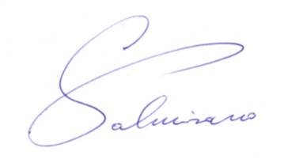 | 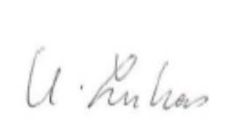
Giuseppe PALMISANO  Rapporteur | Karin LUKAS  President | Henrik KRISTENSEN  Deputy Executive Secretary

