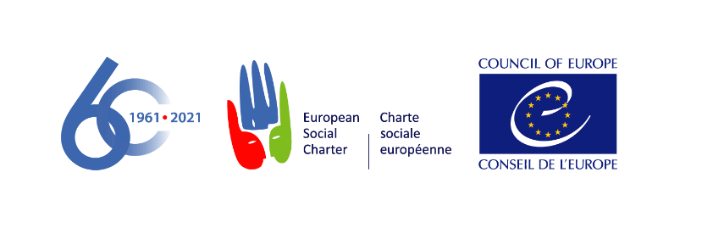

European Committee of Social Rights
Comité européen des Droits sociaux

DECISION ON ADMISSIBILITY

8 September 2021

Norwegian Association of Small & Medium Enterprises (SMB Norge) v. Norway

Complaint No. 198/2021

The European Committee of Social Rights, committee of independent experts established under Article 25 of the European Social Charter (“the Committee”), during its 322nd session attended by:

Karin LUKAS, President
Eliane CHEMLA, Vice-President
Aoife NOLAN, Vice-President
Giuseppe PALMISANO, General Rapporteur
József HAJDU
Barbara KRESAL
Kristine DUPATE
Karin Møhl LARSEN
Yusuf BALCI
Ekaterina TORKUNOVA
Tatiana PUIU
Paul RIETJENS
George THEODOSIS
Mario VINKOVIC
Miriam KULLMANN

Assisted by Henrik KRISTENSEN, Deputy Executive Secretary

Having regard to the complaint registered on 26 March 2021 as number 198/2021, lodged by the Norwegian Association of Small & Medium Enterprises (SMB Norge), and signed by Attorney Nicolay Skarning, Partner at Kvale Advokatfirma, Oslo, on behalf of SMB Norge pursuant to an authorisation dated 22 March 2021 and signed by Ove Bjørn Olsen, Chairman of the board of SMB Norge, requesting the Committee to find that the situation in Norway is not in conformity with Article 24 of the Revised European Social Charter (“the Charter”);

Having regard to the observations of the Government of Norway ("the Government") on the admissibility of the complaint, registered on 31 May 2021;

Having regard to the Charter and, in particular to Article 24, which reads as follows:

Article 24 – The right to protection in cases of termination of employment

Part I: “All workers have the right to protection in cases of termination of employment”.

Part II: “With a view to ensuring the effective exercise of the right of workers to protection in cases of termination of employment, the Parties undertake to recognise:

a. the right of all workers not to have their employment terminated without valid reasons for such termination connected with their capacity or conduct or based on the operational requirements of the undertaking, establishment or service;

b. the right of workers whose employment is terminated without a valid reason to adequate compensation or other appropriate relief.

To this end the Parties undertake to ensure that a worker who considers that his employment has been terminated without a valid reason shall have the right to appeal to an impartial body.”

Having regard to the 1995 Additional Protocol to the European Social Charter providing for a system of collective complaints (“the Protocol”);

Having regard to the Rules of the Committee adopted by the Committee on 29 March 2004 at its 201st session and last revised on 19 May 2021 at its 320th session ("the Rules”);

Having deliberated on 8 September 2021;

Delivers the following decision, adopted on this date:

- SMB Norge alleges that the current system of selecting lay judges to sit in Norwegian courts in employment and dismissal cases violates Article 24 (the right to protection in cases of termination of employment) of the Charter in that the parties themselves nominate and decide on the lay judges who are to sit in these cases. SMB Norge alleges that this system thus weakens the independence of the courts, especially with regard to the requirement of being an "impartial body".

- In its observations, the Government does not contest that the admissibility conditions in the Protocol are fulfilled. The Government also considers that SMB Norge should be deemed as a representative employers’ organisation for the purposes of the collective complaints procedure. Furthermore, the Government considers that the complaint meets the requirements of Article 4 of the Protocol.

THE LAW

- The Committee notes that in accordance with Article 4 of the Protocol, which was ratified by Norway on 20 March 1997 and entered into force for this State on 1 July 1998, the complaint has been submitted in writing and concerns Article 24 of the Charter, a provision accepted by Norway when it ratified the Charter on 7 May 2001. Norway is thus bound by this provision since the entry into force of this treaty in its respect on 1 July 2001.

- The Committee notes that SMB Norge represents approximately 5,273 small and medium-sized businesses. Exercising its activities in Norway, SMB Norge is an employers’ organisation within the jurisdiction of this country as required by Article 1 (c) of the Protocol. Moreover, SMB Norge is recognized by the authorities as an independent organisation.

- The Committee has already considered that SMB Norge, formerly named Bedriftsforbundet, is a representative employers’ organisation for the purposes of the collective complaints procedure, (Bedriftsforbundet v. Norway, Complaint No. 103/2013, decision on admissibility of 14 May 2014, §18). The organisation changed its name from Bedriftsforbundet to SMB Norge on 11 July 2019. The Committee maintains its position in this respect, also noting that the Government considers SMB Norge to be a representative organisation.

- The Committee notes that the complaint submitted on behalf of SMB Norge is signed by Attorney Nicolay Skarning, Partner at Kvale Advokatfirma, Oslo, entitled to represent the organisation in respect of this complaint, as established by the authorisation signed by Ove Bjørn Olsen, Chairman of the board of SMB Norge, who, according to Section 14 of its Statutes, is entitled to issue a power of attorney on behalf of the organisation. The Committee therefore considers that the complaint complies with Rule 23.

- The Committee notes that the grounds of the complaint are indicated, detailing in what respect SMB Norge considers that Norway has not ensured the satisfactory application of the Charter. On this basis, the Committee considers that the complaint fulfils the requirements set out in Article 4 of the Protocol

- For these reasons, the Committee, on the basis of the report presented by Karin Møhl LARSEN, and without prejudice to its decision on the merits of the complaint,

DECLARES THE COMPLAINT ADMISSIBLE

In application of Article 7§1 of the Protocol, requests the Executive Secretary to notify the complainant organisation and the Respondent State of the present decision, to transmit it to the parties to the Protocol and the States having submitted a declaration pursuant to Article D paragraph 2 of the Charter, and to publish it on the Council of Europe´s Internet site.

Invites the Government to make written submissions on the merits of the complaint by 29 October 2021.

Invites SMB Norge to submit a response to the Government’s submissions by a deadline which the Committee shall determine.

Invites the Parties to the Protocol and the States having submitted a declaration pursuant to Article D paragraph 2 of the Charter to notify by 29 October 2021 any observations they may wish to submit.

In application of Article 7§2 of the Protocol, invites the international organisations of employers or workers mentioned in Article 27§2 of the European Social Charter to make observations by 29 October 2021.

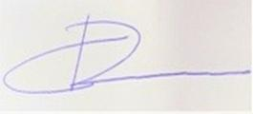 | 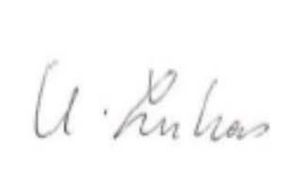
Karin Møhl LARSEN  Rapporteur | Karin LUKAS  President | Henrik KRISTENSEN  Deputy Executive Secretary

